e-ISSN 2580 - 0752
BULLETIN OF
GEOLOGY
Fakultas Ilmu dan Teknologi Kebumian (FITB)
Institut Teknologi Bandung (ITB)
TITLE IN CAPITAL REPRESENTS THE CONTENT OF THE PAPER

FIRST AUTHOR¹, SECOND AUTHOR ², THIRD AUTHOR ³

- PT. Sarana Prasarana, Jakarta, Jl. Soekarno-Hatta No. 12, Jakarta,Email: misfit3472@gmail.com
- Program Studi Teknik Geologi, Fakultas Ilmu dan Teknologi Kebumian, Institut Teknologi Bandung (ITB), Jl. Ganesha No.10, Bandung, Jawa Barat, Indonesia.
- Pusat Survey Geologi, Badan Geologi, ESDM, Jl. Diponegoro No. 57, Bandung, Jawa Barat, Indonesia.

Sari – Sari adalah ringkasan makalah yang lebih informatif daripada judul. Jika seseorang sudah membaca judul dan menunjukkan ketertarikan pada suatu makalah maka ia akan membaca Sari untuk mendapatkan informasi lebih lengkap tentang isi makalah tersebut. Karena Sari adalah ringkasan makalah maka Sari harus memuat informasi tentang apa yang dikerjakan dan apa yang dihasilkan dalam penelitian tersebut.

Kata kunci: Makalah, ringkasan, informasi, penelitin

Abstract - Abstract is a summary of papers that are more informative than titles. If someone has read the title and shows interest in a paper, he will read Abstract to get more complete information about the contents of the paper. Because Abstract is a summary of the paper, Abstract must contain information about what is done and what is produced in the research.

Key words: Paper, summary, information, research

1. INTRODUCTION

“Noken” area inside Akimeugah basin is located in the southern of Papua (Figure 1), covers onshore and offshore area, categorized as a prospective basin based on many hydrocarbon shows on the outcrops and wells (Suliantara dan Susantoro, 2013). There are more uncertainty of oil and gas discovery in this area, caused by lack of intensive research in the tectonic setting to hydrocarbon prospectivity. Mesozoic interval as the objective of this paper resulted by previous post drill recommendation in the surrounding area of “Noken” (Miharwatiman, 2013). “Noken” area (Figure 1) is a part of greater Akimeugah Basin, confined geographically by Asmat Thrust or Sepik terrane in the north (Hall, 2002), Tasman Line in the east (Bally et al., 2012; Hill and Hall, 2003), Merauke Arch in the West (Moss, 2001) and Aru High or Tarera-Aiduna Fault in the West (Cloos et al., 2005).

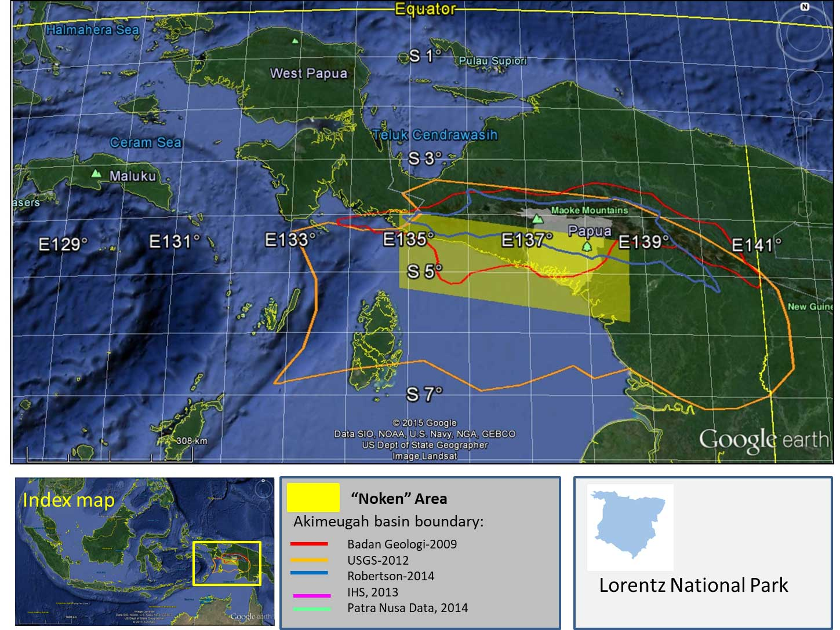
Figure 1. “Noken” Area inside all published basin boundaries of Akimeugah Basin (Patra Nusa Data, 2014; Robertson -A CGG Company, 2014; Schenk et al., 2012; Sukhyar et al., 2009; The Ministry of Forestry, 1997), basemap using Google (2015).

2. DATA AND METHODOLOGY
Data used in this research are grouped into two kind of data: primary and secondary. The primary data divided into four data, wells, seismic, gravity and magnetic. Three of 13 wells (Figure 2) were used to create input density data of all geological era from Cenozoic to Paleozoic. 53 lines of multiple years and company seismic data were interpreted after miss-tie analysis and well-seismic tie using two-way-time depth conversion from 7 wells.

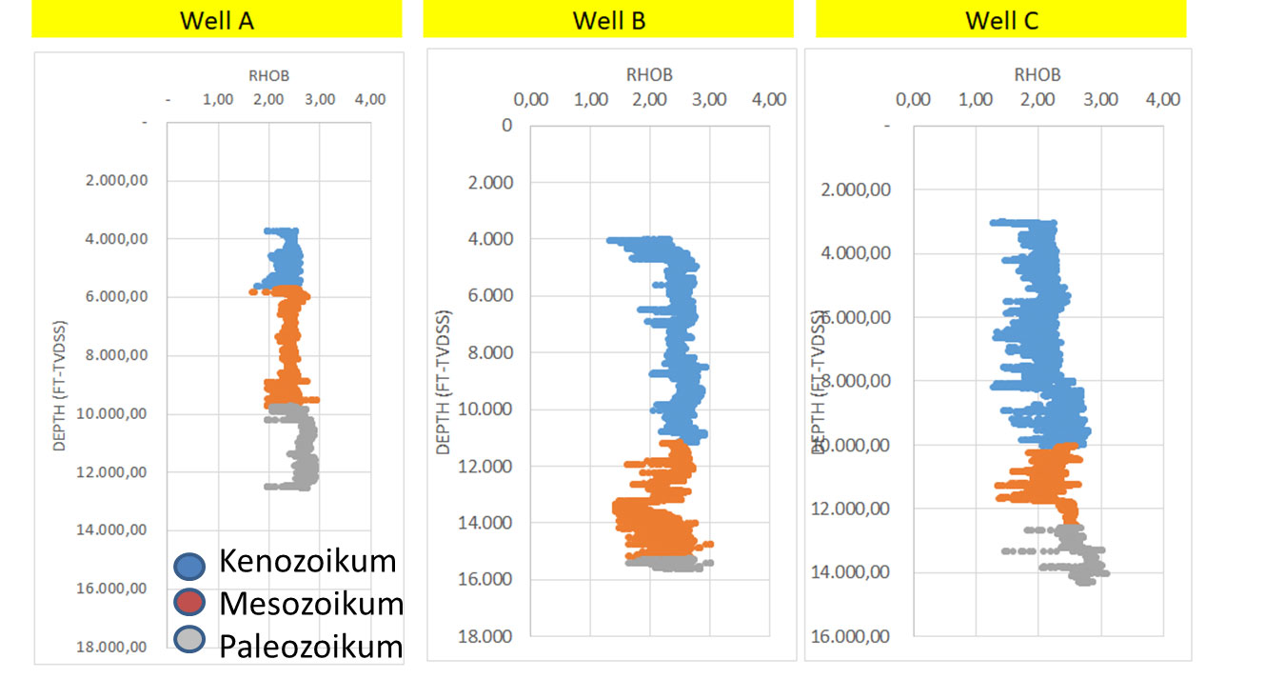
Figure 2. Three wells have density data in all geological era.

Gravity data are taken from satellite (Sandwell et al., 2014), Asmat field measurements (Padmawidjaja, 2014), and regional gravity data (Hayat and Nasution, 2008; Hayat, 2008; Hayat and Raharjo, 2009; Hayat and Sobari, 2010; Setyanta et al., 2008; Sobari et al., 2008; Sobari and Hayat, 2008, 2008; Susilo and Hayat, 2008). Magnetic anomaly data that used in this paper are EMAG (Earth Magnetic Anomaly Grid, (Maus, 2010; Maus et al., 2007) and airborne total intensity of magnetism (Nurmailah and Suyono, 2013; Setyanta, 2013c, 2013e, 2013b, 2013d, 2013a; Setyanta and Suyono, 2013; Siagian, 2013b, 2013a, 2008; Siagian and Mawardi, 2013; Siagian and Suyono, 2013; Widijono, 2013b, 2013d, 2013c, 2013f, 2013a, 2013e).

Secondary data resulted from field samples, field geological structures measurements, and tops of geological age marker using paleontology samples from well reports to control geological interpretation and reconstruction.

3. RESULTS
There are three geological interpretations resulted from gravity and magnetic modeling with the help of well and seismic correlations above: the interpretation of bedrock, the interpretation of geological structures and the map of subsurface structures. Gravity model crossing NW-SW (Figure 3) show Pre-Paleozoic rocks. Gravity model crossing west-east section prove the syn-rift geometry in the Mesozoic interval.

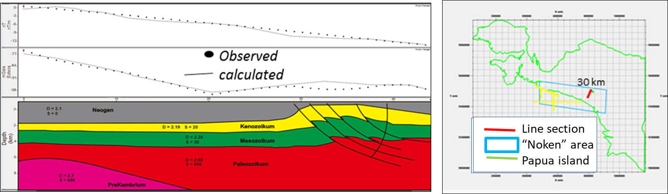
Figure 3. Gravity model of NE-SW section (gravity track is red-lined on the map).

Isopach map was constructed in the Mesozoic interval, adding a strong suspicion of strike-slip fault pattern that generated graben – half graben during Mesozoic Era. There are six unparalleled strike-slip faults inferred as rhomboidal basin deep development mainly between fault S3 and fault S4 during Mesozoic.

The association of sinistral strike-slip faults in this research during Mesozoic is not explained by previous studies (Hall, 2012; Struckmeyer, 1991) in the "Noken" area. The explanation of the sinistral strike-slip faults have two possibilities, associated to Triassic back-arc basin development, of caused by Mesozoic to present-day intracratonic strike-slip fault. The simple scheme of this explanation in Figure 4.
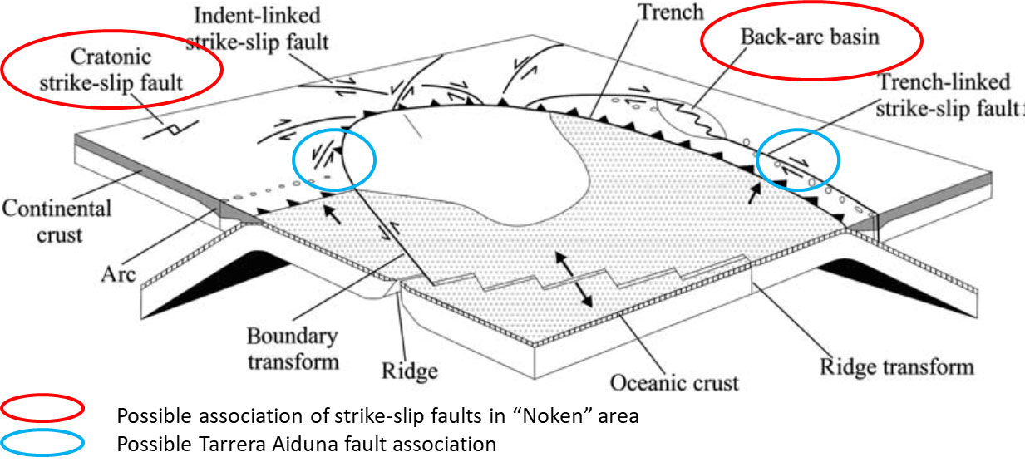
Figure 4. Possibility of strike-slip fault associations in “Noken” area based on strike-slip tectonic setting (modified from Woodcock, 1986 in Mann, 2007).

5. CONCLUSION
Based on the analysis of the structure of the subsurface geological structure map of the Mesozoic and Cenozoic, gravity sections and models can be interpreted that tectonic evolution during Cenozoic changes the geometry of the basin became trending northwest-southeast.

ACKNOWLEDGMENT
The authors thank to Center for Geological Survey management and staff for the office study internship.

REFERENCES
Alotaibi, B., 2016, Two Manual Ways to Interpret Gravity Anomaly:, https://prezi.com/qo7lc2xwwasu/two-manual-ways-to-interpret-gravity-anomaly/ (accessed September 2016).
Baillie, P., Fraser, T., Hall, R., and Myers, K., 2003, Geological development of Eastern Indonesia and the northern Australia collision zone: a review, in Proceedings of the Timor Sea Symposium, Darwin, Northern Territory, Australia, June 19–10, p. 539–550, http://searg.rhul.ac.uk/pubs/baillie_etal_2004.pdf (accessed May 2015).
Bally, A.W., Roberts, D.G., Sawyer, D., and Sinkewich, A., 2012, Tectonic and Basin maps of the world, in Regional Geology and Tectonics: Phanerozoic Passive Margins, Cratonic Basins and Global Tectonic Maps, Elsevier, p. 970–1151, http://linkinghub.elsevier.com/retrieve/pii/B978044456357600024X (accessed August 2015).
Childers, V.A., McAdoo, D.C., Brozena, J.M., and Laxon, S.W., 2001, New Gravity Data in the Arctic Ocean: Comparison of Airborne and Ers Gravity: Journal of Geophysical Research: Solid Earth, v. 106, p. 8871–8886, doi: 10.1029/2000JB900405.
Cloos, M., Sapiie, B., Ufford, A.Q. van, Weiland, R.J., Warren, P.Q., and McMahon, T.P., 2005, Collisional Delamination in New Guinea: The Geotectonics of Subducting Slab Breakoff: Boulder, Colo, Geological Society of America, Special paper 400, 51 p.
Geisler, O., and Krieger, M., 2011, Reducing Uncertainty in Subsalt Imaging with Gravity and FTG:, www.terrasysgeo.com.
Gibson, R.I., and Millegan, P.S. (Eds.), 1998, Geologic Applications of Gravity and Magnetics: Case Histories: Society of Exploration Geophysicists and American Association of Petroleum Geologists, http://library.seg.org/doi/book/10.1190/1.9781560801832 (accessed December 2016).
Google, 2015, Google Maps:, https://www.google.com/maps (accessed June 2015).
Granath, J.W., and Agrakoesoemah, R.M.., 1989, Variations in Structural Style Along the Eastern Central Range Thrust Belt, Irian Jaya: PROCEEDINGS IPA, v. Eighteenth Annual Convention, p. 11.
Hall, R., 2002, Cenozoic geological and plate tectonic evolution of SE Asia and the SW Pacific: computer-based reconstructions, model and animations: Journal of Asian Earth Sciences, v. 20, p. 353–431.
Hall, R., 2012, Late Jurassic–Cenozoic reconstructions of the Indonesian region and the Indian Ocean: Tectonophysics, v. 570–571, p. 1–41, doi: 10.1016/j.tecto.2012.04.021.
Hayat, D.Z., 2008, Peta Anomali Bouguer Lembar Sarabih, Papua: Pusat Penelitian dan Pengembangan Geologi.
Hayat, D.., and Nasution, J., 2008, Peta Anomali Bouguer Lembar Rotanburg, Papua: Pusat Penelitian dan Pengembangan Geologi.

